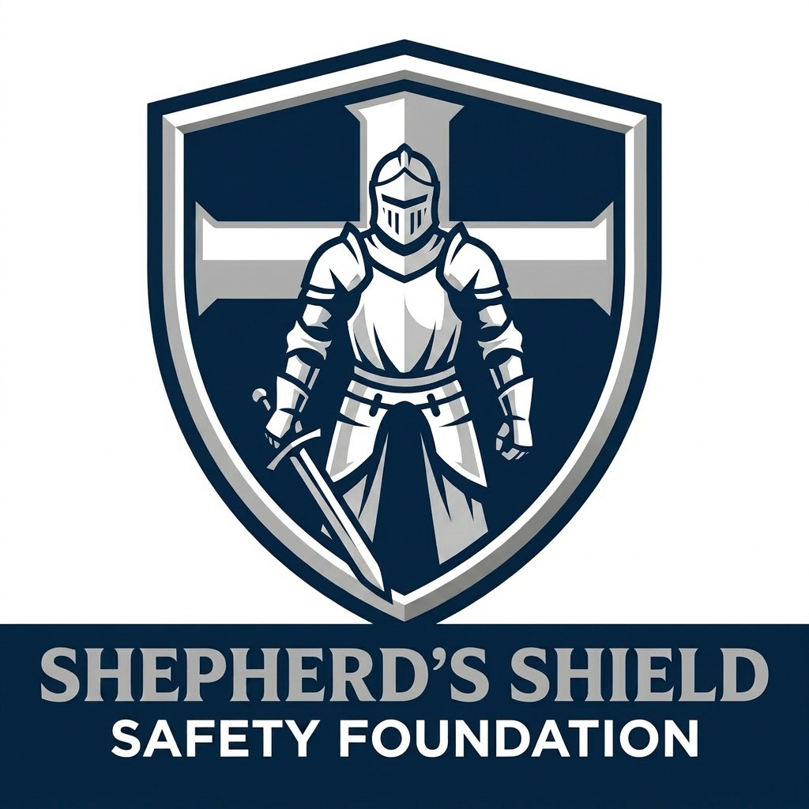 | SHEPHERD'S SHIELD SAFETY FOUNDATION  "Protecting the Flock. Preserving Life. Glorifying God."

MODULE 2 | THE HOW ASSESSMENT TOOL — DEEP DIVE

Mastering the Foundation's Core Evaluation Instrument

LEARNING OBJECTIVES

- Navigate the HOW Security Assessment tool confidently
- Explain the purpose and focus of all 10 security pillars
- Apply the correct scoring values (YES, PARTIAL, NO, N/A) consistently
- Calculate pillar scores and understand what each score range means
- Identify the most common scoring errors and how to avoid them

2.1 — WHAT IS THE HOW ASSESSMENT TOOL?

The HOW Security Assessment is SSSF's proprietary evaluation instrument. HOW stands for Houses of Worship. It was developed specifically for faith communities — not adapted from a corporate or government security framework. Every question in the tool was designed with the unique culture, vulnerabilities, and resources of a house of worship in mind.
The tool is structured as a scored checklist covering 10 security pillars. Each pillar addresses a distinct area of congregational security. Together they create a complete picture of a facility's current security posture — what is working, what is missing, and where to focus first.
The HOW Tool Is Password Protected
The HOW Assessment tool is proprietary SSSF intellectual property. The file is password-protected (SSSF2026) and is never delivered to clients in its entirety. Only the Summary Report is shared with client leadership.

2.2 — THE 10 SECURITY PILLARS

Pillar | Title | What It Evaluates
Pillar 1 | Security Management & Planning | Evaluates governance structure, written security plan, assigned leadership roles, coordination across all ministry departments, and relationships with law enforcement and first responders.
Pillar 2 | Perimeter Security & Grounds | Evaluates fencing, natural barriers, exterior lighting, landscaping (CPTED standards), vehicle-as-a-weapon (VAAW) mitigation measures, and IED concealment location assessment.
Pillar 3 | Parking & Traffic Safety | Evaluates parking lot operations, traffic control during peak services, pedestrian pathways and crosswalks, VAAW mitigation at drop-off zones, and volunteer direction protocols.
Pillar 4 | Access Control & Entry Points | Evaluates main and secondary entrance control, visitor management processes (sign-in, ID issuance, sign-out), key inventory and management, electronic access control systems, and exit security.
Pillar 5 | Video Surveillance Systems | Evaluates camera coverage of interior and exterior areas, recording capability, minimum 30-day retention standards, active monitoring protocols, and system maintenance practices.
Pillar 6 | Communications & Duress Systems | Evaluates dedicated security radio systems, duress alarms and panic buttons, mass notification capability for the congregation, and formal interoperability protocols with local law enforcement.
Pillar 7 | Emergency Action Plans & Drills | Evaluates written emergency procedures for all threat scenarios (active threat, fire, medical, severe weather), designated evacuation routes and rally points, drill history, and congregant instruction.
Pillar 8 | Security Team Readiness | Evaluates team composition and role assignments, written standard operating procedures (SOPs), use-of-force policy, armed qualification standards, de-escalation training, and ongoing training curriculum.
Pillar 9 | Medical & First Aid Readiness | Evaluates AED availability and team certification, first aid supplies, formally trained and designated first responders, a written medical response plan, and EMS pre-notification protocols.
Pillar 10 | Interior Facility & Children's Wing | Evaluates exit signage compliance, classroom and office security, children's ministry access controls, interior lockdown protocols, and cash/offering handling dual-accountability procedures.

2.3 — THE SCORING SYSTEM

Each question in the HOW Assessment tool is scored using one of four values. Consistent, accurate scoring is the foundation of a credible assessment. Never guess. Never score based on what you are told — only on what you directly observe.
Score Value | Meaning | When to Use It
YES (2 points) | Fully meets the standard | The item is clearly present, functional, and meets the intent of the question. You observed it directly.
PARTIAL (1 point) | Partially meets the standard | Something exists but is incomplete, inconsistent, non-functional, or only partially implemented.
NO (0 points) | Does not meet the standard | The item is absent, broken, or clearly does not meet the standard. Score NO based on what you see — not what they say they plan to do.
N/A | Not applicable | The question genuinely does not apply to this facility type or configuration. Use sparingly and document the reason.

The Golden Rule of Scoring
"Score what you SEE — not what you are TOLD." If a pastor says "we have an emergency plan but I don't have it with me today," that is a PARTIAL at best — and possibly a NO if no written plan can be produced. Documentation must exist and be accessible to score YES.

2.4 — HOW SCORES ARE CALCULATED

Each pillar is scored out of 10 points. The tool automatically calculates pillar scores and an overall assessment score when used digitally. Understanding the math behind the scores helps you interpret results accurately.
Pillar Score Formula: (Points Earned ÷ Points Possible) × 10
N/A items are excluded from both points earned and points possible — they do not penalize the score.

Score Ranges & What They Mean
Score Range | Rating | Interpretation
9.0 – 10.0 | Excellent | Strong security posture. Maintain and build on existing strengths.
7.0 – 8.9 | Good | Solid foundation with specific areas for improvement.
5.0 – 6.9 | Developing | Meaningful gaps exist. Priority action plan needed.
3.0 – 4.9 | Vulnerable | Significant vulnerabilities. Immediate attention required in multiple areas.
0.0 – 2.9 | Critical | Severe deficiencies across the board. Urgent intervention needed.

2.5 — COMMON SCORING MISTAKES

❌ Scoring YES because staff say it exists — not because you saw it.
✅ Always verify. Ask to see the document, the equipment, the plan.
❌ Using PARTIAL as a default when unsure.
✅ If you are unsure, ask more questions. Don't default to PARTIAL out of politeness.
❌ Over-using N/A.
✅ N/A is for questions that genuinely don't apply — not for items that are inconvenient to score. Document your reason every time.
❌ Scoring based on intent, not reality.
✅ 'We plan to install cameras next month' is a NO today. Score what exists now.
❌ Rounding up scores to avoid difficult conversations.
✅ An inflated score does the congregation no favors and puts SSSF's credibility at risk.
❌ Not documenting your observations in the Notes section.
✅ Your notes are what make the report meaningful. A score without context is just a number.

2.6 — THE SUMMARY REPORT

The Summary Report is the only portion of the HOW Assessment tool that is shared with client leadership. It contains:
- Overall assessment score and rating
- Individual pillar scores and ratings
- Critical deficiency flags — items that scored 0 (NO) across key safety areas
- Assessor notes and observations for each pillar
- Sign-off block for the lead assessor and SSSF authorization

Protect the Full Assessment
The full scored checklist — all 101 questions with individual scores — is SSSF proprietary property and is NEVER given to the client. The full assessment remains in SSSF records. The client receives the Summary Report only.

KEY TAKEAWAYS

- The HOW Tool covers 10 security pillars — each addressing a distinct area of congregational vulnerability.
- Use four scoring values: YES (2), PARTIAL (1), NO (0), N/A. Score only what you directly observe.
- Scores are calculated as a percentage of possible points per pillar, expressed on a 0–10 scale.
- The most common mistake is scoring YES or PARTIAL based on what you are told rather than what you see.
- The client receives the Summary Report only — the full assessment is SSSF proprietary.

KNOWLEDGE CHECK

Answer the following questions to confirm your understanding of this module. These will be reviewed with your instructor.

1. How many security pillars does the HOW Assessment tool cover?
- A) 6
- B) 8
- C) 10
- D) 12

2. A church says they have an emergency plan but cannot produce it during the assessment. What score do you give?
- A) YES — they said they have it
- B) PARTIAL — they claim it exists but cannot verify
- C) NO — documentation must be present and accessible
- D) N/A — it doesn't apply to this situation

3. What does a pillar score of 3.2 indicate?
- A) Excellent security posture
- B) Good foundation with minor gaps
- C) Significant vulnerabilities requiring urgent attention
- D) The pillar was not assessed

4. When is it appropriate to use N/A?
- A) When you are unsure how to score a question
- B) When a question genuinely does not apply to the facility type or configuration
- C) When the congregation cannot answer the question
- D) When you want to avoid a difficult conversation

5. Which portion of the HOW Assessment is shared with the client?
- A) The full 101-question scored checklist
- B) The pillar notes only
- C) The Summary Report
- D) All sections except Pillar 7

NOTES

_____________________________________________________________________________________
_____________________________________________________________________________________
_____________________________________________________________________________________
_____________________________________________________________________________________
_____________________________________________________________________________________
_____________________________________________________________________________________
_____________________________________________________________________________________
_____________________________________________________________________________________
_____________________________________________________________________________________
_____________________________________________________________________________________
_____________________________________________________________________________________
_____________________________________________________________________________________
_____________________________________________________________________________________
_____________________________________________________________________________________
_____________________________________________________________________________________
_____________________________________________________________________________________
_____________________________________________________________________________________
_____________________________________________________________________________________

