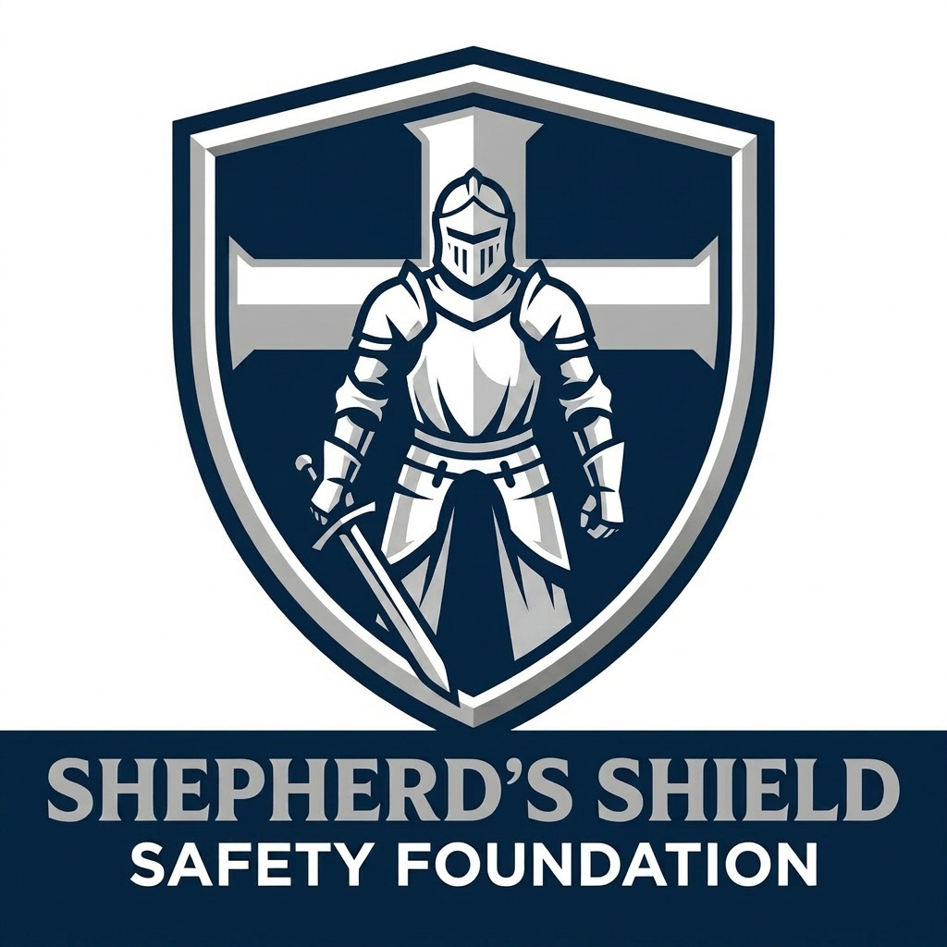 | SHEPHERD'S SHIELD SAFETY FOUNDATION  "Protecting the Flock. Preserving Life. Glorifying God."

MODULE 10 | SHADOW ASSESSMENT PREPARATION & CERTIFICATION EXAM PREP

Your Final Step to SSSF Certification

PART 1 — THE SHADOW ASSESSMENT

What Is a Shadow Assessment?
A shadow assessment is a complete, live SSSF engagement at a real client church, synagogue, or house of worship. You accompany the lead assessor through the full process — from arrival through debrief. You observe, take your own independent notes, score independently, and compare your results with the lead assessor afterward. You do not lead any portion of the live engagement.
Shadow Rule: Observe First, Engage Second
Your primary role is to observe simultaneously — the lead assessor's technique AND the facility. Do not interject during interviews, do not offer unsolicited observations to the client, and do not share your scores aloud during the engagement. Your time to discuss comes in the post-assessment debrief with your lead assessor.

Before the Shadow Assessment — Preparation Checklist
- Confirm date, time, location, and point of contact with the lead assessor
- Review your HOW Assessment tool — know all 10 pillars and all scoring criteria cold
- Review Modules 1–9 notes — refresh key principles and observation techniques
- Prepare your materials: HOW Assessment tool, notebook, pen, SSSF photo ID
- Dress professionally — business casual unless lead assessor specifies otherwise
- Arrive 15 minutes early — never keep a client waiting
- Review your signed NDA (Policy 1) and Code of Ethics (Policy 3) — you operate under both

During the Shadow Assessment — What You Should Be Doing
- Observing the lead assessor's technique: How do they build rapport? Frame questions? Handle resistance?
- Conducting your own parallel scoring: Score each pillar independently. Do NOT look at the lead assessor's scores during the assessment.
- Taking detailed, zone-by-zone notes: Specific, time-stamped, evidence-based — exactly as trained in Module 5.
- Noting questions you would have asked: If the lead moves past something you would have explored, note it for the debrief.
- Staying professional in all interactions: Even as a shadow, your demeanor represents SSSF.

Shadow Assessor Field Observation Form
Pillar | My Score (0–10) | Key Observations | Questions I Would Have Asked
P1: Physical Security & Access Control
P2: Personnel & Staffing
P3: Communications
P4: Medical & Emergency Response
P5: Parking & Exterior Security
P6: Worship Service Security
P7: Children & Youth Security
P8: Technology & Surveillance
P9: Crisis & Incident Management
P10: Training & Preparedness

Post-Shadow Debrief with Lead Assessor
- Compare your pillar scores to the lead assessor's — where did you align? Where did you differ, and why?
- Review your observation notes — what did you catch well? What did you miss?
- Discuss interview observations — how would you have asked questions differently?
- Identify one moment where you were uncertain — discuss how to handle it next time.
- Discuss the debrief you observed — what was effective? What would you do differently?
- Lead assessor shares their overall assessment of your readiness.

Lead Assessor Evaluation Criteria
Criterion | What It Measures
Professionalism | Appearance, demeanor, punctuality, and conduct throughout
Observation Skills | Quality and thoroughness of independent notes and zone coverage
Scoring Accuracy | Alignment with lead assessor scores; ability to explain discrepancies
Advisor Mindset | Demonstrated understanding of advisor vs. inspector approach
Policy Compliance | Adherence to confidentiality, photography rules, scope, and Code of Ethics
Readiness Recommendation | Ready / Needs Additional Preparation / Not Yet Ready

PART 2 — CERTIFICATION EXAM PREPARATION

After successfully completing your shadow assessment, you will sit for the SSSF Written Certification Exam administered by the President or a designated Tier C assessor. This is a closed-book, closed-notes evaluation. You may not reference any training materials during the exam.
How the Exam Is Delivered
The exam is administered in person or via Zoom under direct supervision. You will not have access to your training documents, the HOW Assessment tool, or your notes during the exam. The exam tests whether you have genuinely internalized the material — not whether you can find the right page.

WHAT THE EXAM COVERS — TOPIC AREAS

The exam draws from all 10 training modules. The following topic areas will be tested. Study each one until you can explain it clearly from memory — without notes.
Topic | Title | What to Know
Topic 1 | SSSF Mission & Philosophy | Be able to explain SSSF's mission in your own words, the de-escalation-first principle, and why the foundation operates on a faith-centered philosophy. Know the five founding board members and their roles.
Topic 2 | The 10 Security Pillars | Know all 10 pillars by name — in order and out of order. Be able to describe what each pillar evaluates in 1–2 sentences. This is frequently tested.
Topic 3 | Scoring Methodology | Know all four scoring values (YES, PARTIAL, NO, N/A), their point values, and exactly when to use each one. Understand the golden rule: score what you SEE, not what you are told.
Topic 4 | Score Calculation & Ranges | Understand how pillar scores are calculated. Know all five score rating labels and what each range means (Excellent, Good, Developing, Vulnerable, Critical).
Topic 5 | Walk-Through Methodology | Know the outside-in sequence. Be able to describe what to look for in each zone (parking lot, building exterior, vestibule, worship space, children's area, technology).
Topic 6 | Observation & Documentation | Know the Three-Part Note Formula. Understand photography rules. Be able to describe the most commonly missed vulnerabilities.
Topic 7 | Interviewing Skills | Know the three question types (open-ended, closed/verification, probing) and when to use each. Be able to describe how to handle a defensive, resistant, or overwhelmed leader.
Topic 8 | Legal & Scope Awareness | Know what an SSSF assessment IS and IS NOT. Know the five types of statements that create liability. Know mandatory reporting triggers and what to do when they occur.
Topic 9 | Report Writing & Recommendations | Know the Three-Part Note Formula by heart. Know the three priority tiers and be able to give examples at each level. Know how to conduct a debrief and handle difficult reactions.
Topic 10 | SSSF Policies & Certification | Know all six SSSF policies by number, title, and general purpose. Know the certification structure (Tier A, B, C). Know the founding board provision and the volunteer commitment standard.

MUST-MEMORIZE LIST

These are the specific facts, lists, and frameworks you must be able to recall from memory on exam day. Flash card them. Say them out loud. Write them out. Know them cold.

1. The 10 Security Pillars — In Order
- Physical Security & Access Control
- Personnel & Staffing
- Communications
- Medical & Emergency Response
- Parking & Exterior Security
- Worship Service Security
- Children & Youth Security
- Technology & Surveillance
- Crisis & Incident Management
- Training & Preparedness

2. The Four Scoring Values
- YES = 2 points — fully meets the standard, directly observed
- PARTIAL = 1 point — exists but incomplete, inconsistent, or non-functional
- NO = 0 points — absent or does not meet the standard
- N/A = excluded — genuinely does not apply; document the reason

3. The Five Score Rating Labels
- 9.0–10.0 = Excellent
- 7.0–8.9 = Good
- 5.0–6.9 = Developing
- 3.0–4.9 = Vulnerable
- 0.0–2.9 = Critical

4. The Three-Part Note Formula
- Part 1 — What you OBSERVED (specific, factual, location-stamped)
- Part 2 — Why it MATTERS (plain-language security implication)
- Part 3 — What to DO (concrete, achievable recommendation)

5. The Three Recommendation Priority Tiers
- Priority 1 — Immediate Action (within 30 days): high-risk, low/no budget required
- Priority 2 — Near-Term Action (within 90 days): meaningful gaps, some budget needed
- Priority 3 — Long-Term Planning (6–12 months): infrastructure or programmatic investment

6. The Six SSSF Policies — By Number and Title
- Policy 1 — Confidentiality & Non-Disclosure
- Policy 2 — Conflict of Interest
- Policy 3 — Assessor Code of Ethics & Conduct
- Policy 4 — Client Engagement & Service Agreement
- Policy 5 — Donation Acceptance
- Policy 6 — Assessor Credentialing & Certification

7. Mandatory Reporting Triggers
- Evidence of imminent danger to any person
- Active criminal activity observed during the assessment
- Evidence of child abuse, neglect, or endangerment
- Observable threats to the physical safety of the congregation

8. The Outside-In Walk-Through Sequence
- Observe from parking lot before entering
- Walk full exterior perimeter
- Enter through primary public entrance
- Assess entry zone (vestibule/foyer)
- Move through public spaces and hallways
- Assess main worship space
- Assess children's and youth areas
- Assess secondary and utility spaces
- Return to central location and review notes for gaps

9. Five Statements That Create Liability
- Guarantees of safety or security outcomes
- Specific vendor or product endorsements
- Legal or regulatory statements
- Diagnoses of imminent danger or facility condemnation
- References to specific incidents at other organizations

10. The Three Certification Tiers
- Tier A — Assessor Candidate: training phase, no independent scoring, unpaid
- Tier B — Certified Assessor: board-approved, can assess independently, compensated for completed engagements
- Tier C — Senior Assessor / Lead Trainer: 2+ years exemplary service, board-elevated, can train others

PRACTICE TEST — EXAM STYLE QUESTIONS

These practice questions are written in the same format and style as the actual certification exam — but they are NOT the exam questions. Use them to test your knowledge and identify areas to review. Try to answer each one without looking at your notes first.

Practice Question 1: Name the 10 security pillars of the HOW Assessment tool in order.
Study Hint
Practice recalling all 10 from memory. Refer to your Must-Memorize list to check your answer.

Your Answer:
_____________________________________________________________________________________
_____________________________________________________________________________________
_____________________________________________________________________________________
_____________________________________________________________________________________
_____________________________________________________________________________________
_____________________________________________________________________________________

Practice Question 2: A facility manager says 'Our alarm system is monitored 24/7.' When you ask to see the monitoring contract, he cannot locate it. How do you score this and why?
Study Hint
Think about the golden rule: score what you see, not what you're told. What value applies when something is claimed but cannot be verified?

Your Answer:
_____________________________________________________________________________________
_____________________________________________________________________________________
_____________________________________________________________________________________
_____________________________________________________________________________________
_____________________________________________________________________________________
_____________________________________________________________________________________

Practice Question 3: Write a complete three-part note for the following observation: You find two exterior doors on the south side of the building unlocked and unmonitored during a Sunday service.
Study Hint
Apply the Three-Part Note Formula: (1) Specific observation with location, (2) security implication, (3) actionable recommendation.

Your Answer:
_____________________________________________________________________________________
_____________________________________________________________________________________
_____________________________________________________________________________________
_____________________________________________________________________________________
_____________________________________________________________________________________
_____________________________________________________________________________________

Practice Question 4: A pillar has 8 questions. Three score YES (2pts), two score PARTIAL (1pt), two score NO (0pts), and one is N/A. What is the pillar score out of 10?
Study Hint
Points earned: (3×2) + (2×1) + (2×0) = 8. Points possible: 7 questions × 2 = 14. Score: (8÷14) × 10 = 5.7. Rating: Developing.

Your Answer:
_____________________________________________________________________________________
_____________________________________________________________________________________
_____________________________________________________________________________________
_____________________________________________________________________________________
_____________________________________________________________________________________
_____________________________________________________________________________________

Practice Question 5: List the six SSSF policies by number and title.
Study Hint
This is straight memorization. Check your Must-Memorize list. You should be able to recite all six without hesitation.

Your Answer:
_____________________________________________________________________________________
_____________________________________________________________________________________
_____________________________________________________________________________________
_____________________________________________________________________________________
_____________________________________________________________________________________
_____________________________________________________________________________________

Practice Question 6: During an assessment, a children's ministry volunteer tells you privately that a staff member has been left alone with individual children on multiple occasions. What do you do?
Study Hint
Consider your mandatory reporting obligations. Does this qualify? What are your next steps per SSSF policy?

Your Answer:
_____________________________________________________________________________________
_____________________________________________________________________________________
_____________________________________________________________________________________
_____________________________________________________________________________________
_____________________________________________________________________________________
_____________________________________________________________________________________

Practice Question 7: A congregation scores 4.2 overall. How would you describe this in the debrief without using the word 'failure'?
Study Hint
Practice the advisor mindset and debrief tone guidelines from Module 8. Frame as opportunity, not judgment.

Your Answer:
_____________________________________________________________________________________
_____________________________________________________________________________________
_____________________________________________________________________________________
_____________________________________________________________________________________
_____________________________________________________________________________________
_____________________________________________________________________________________

Practice Question 8: What is the difference between cover and concealment? Give one example of each you might find in a worship space.
Study Hint
Recall the definitions from Module 3 and think through the physical environment of a typical sanctuary.

Your Answer:
_____________________________________________________________________________________
_____________________________________________________________________________________
_____________________________________________________________________________________
_____________________________________________________________________________________
_____________________________________________________________________________________
_____________________________________________________________________________________

Practice Question 9: Describe the founding board certification provision. Why does it exist, and what does each member still have to complete?
Study Hint
This tests your knowledge of Policy 6. Think about why the founding board has a special pathway and what the training requirements still are.

Your Answer:
_____________________________________________________________________________________
_____________________________________________________________________________________
_____________________________________________________________________________________
_____________________________________________________________________________________
_____________________________________________________________________________________
_____________________________________________________________________________________

Practice Question 10: You are conducting a debrief and the pastor says 'I think your score for our children's area is wrong — we do have check-in procedures.' How do you respond?
Study Hint
Recall the guidance on handling score disputes from Module 8. What can you and cannot you do?

Your Answer:
_____________________________________________________________________________________
_____________________________________________________________________________________
_____________________________________________________________________________________
_____________________________________________________________________________________
_____________________________________________________________________________________
_____________________________________________________________________________________

Practice Question 11: List the five types of statements that create legal liability for an assessor and give one example of each.
Study Hint
Recall from Module 7. Think through vendor endorsements, guarantees, legal statements, facility condemnation, and incident references.

Your Answer:
_____________________________________________________________________________________
_____________________________________________________________________________________
_____________________________________________________________________________________
_____________________________________________________________________________________
_____________________________________________________________________________________
_____________________________________________________________________________________

Practice Question 12: What are the three recommendation priority tiers? Give one realistic example of a finding that belongs in each tier.
Study Hint
Test your ability to apply the priority framework to real-world findings from Module 8.

Your Answer:
_____________________________________________________________________________________
_____________________________________________________________________________________
_____________________________________________________________________________________
_____________________________________________________________________________________
_____________________________________________________________________________________
_____________________________________________________________________________________

Final Thought Before Your Exam
The exam is not designed to trick you. Every question tests something you genuinely need to know to conduct a safe, credible, professional assessment on behalf of SSSF. If you can walk through the Must-Memorize list without your notes and work through these practice questions with confidence — you are ready. Go into that exam knowing you earned this.

NOTES

_____________________________________________________________________________________
_____________________________________________________________________________________
_____________________________________________________________________________________
_____________________________________________________________________________________
_____________________________________________________________________________________
_____________________________________________________________________________________
_____________________________________________________________________________________
_____________________________________________________________________________________
_____________________________________________________________________________________
_____________________________________________________________________________________
_____________________________________________________________________________________
_____________________________________________________________________________________
_____________________________________________________________________________________
_____________________________________________________________________________________
_____________________________________________________________________________________
_____________________________________________________________________________________
_____________________________________________________________________________________
_____________________________________________________________________________________

